Day-2 SQL SERVER ASSIGNMENT:
4.1 Select commands:
Command: select * from customers;
o/p:
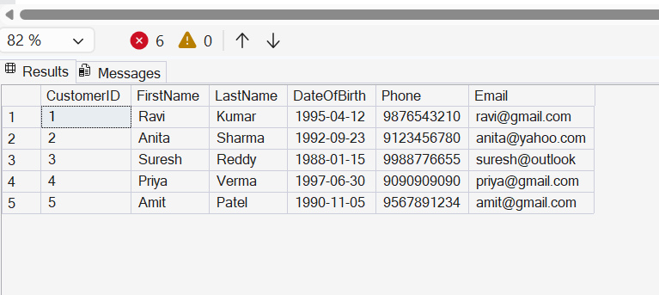

4.2:
Command: select CustomerID, PolicyId, StartDate,EndDate from policyassignments;
o/p:
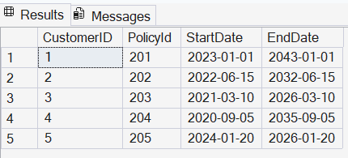
4.3:
Command: select * from policies where policytype='Health';
o/p:
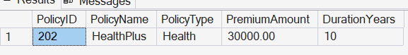

4.4:
Command:select * from policies where premiumamount>10000 and durationyears=1;
o/p:
4.5:
Command: select distinct city from agents;
o/p:
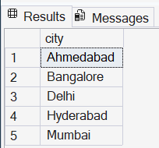
4.6:
Command: select * from policies where policytype='Health' or policytype='Motor';
o/p:
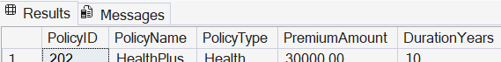
4.7:
Command: select * from policies where policytype in ('Health','Motor');
o/p:
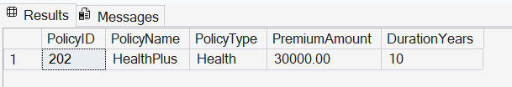
4.8:
Command: select * from customers where DateOfBirth>='2001-01-01' and DateOfBirth<='2020-12-31';
o/p:
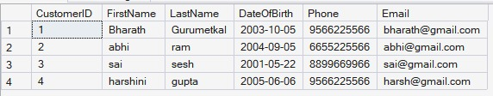
4.9:
Command: select * from customers where DateOfBirth between '2001-01-01' and '2020-12-31';
o/p:
4.10:
Command: select * from claims where claimstatus='Rejected';
o/p:
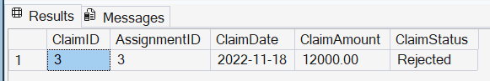
4.11:
Command: select * from agents where city like '_a%';
o/p:
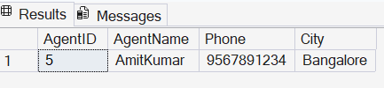

4.12:
Command: select max(claimamount) as max_amount,min(claimamount) as min_amount from claims;
o/p:
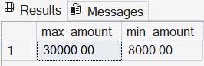
4.13:
Command: select top 1 * from claims
order by claimdate desc;
o/p:
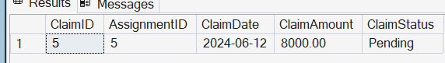

4.14:
Command: update policies set premiumamount=premiumamount*1.10 where policytype='Health';
o/p:
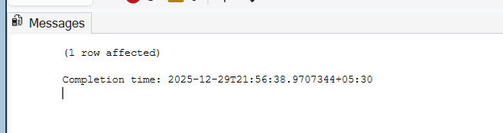

4.15:
Command: delete from policyassignments where enddate<getdate();

o/p:
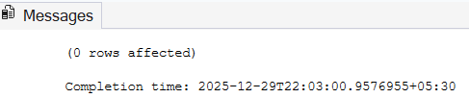
4.16:
Command: select count(*) as countOfRejected from claims where claimstatus='Rejected';
o/p:
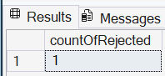
4.17:
Command: select PolicyID,PolicyName,PremiumAmount,
round(PremiumAmount * 0.06, 2) as localTaxes,
round(PremiumAmount + (PremiumAmount * 0.06), 2) as AmountWithTax,
round(PremiumAmount / 12.0, 2) as MonthP from Policies;
o/p:
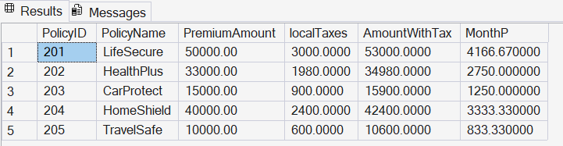

4.18:
Command: alter table customers add Address varchar(100),city varchar(50);
o/p:
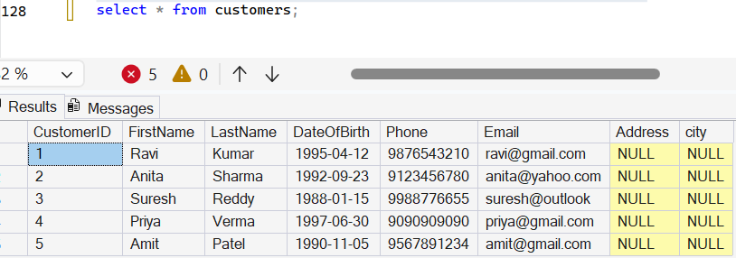

4.19:
Command: alter table agents add DevelopmentOfficerId int;
o/p:
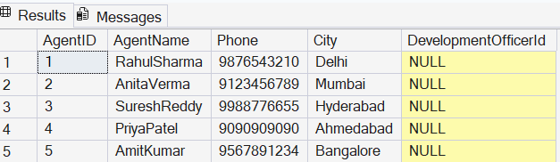
4.20:
Command: alter table agents add constraint fk_devofcId foreignkey(DevelopmentOfficerId) references agents(agentid);
o/p:
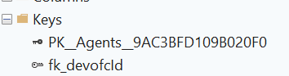

Joins, Group By, Having

5.1:
Command: select p.PolicyID,p.PolicyName,pa.StartDate,pa.EndDate
from PolicyAssignments pa join Policies p on pa.PolicyID = p.PolicyID
where pa.CustomerID = 5;
o/p:
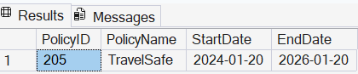

5.2:
Command: select c.CustomerID,c.FirstName,c.LastName,p.PolicyID,p.PolicyName,p.PolicyType,p.PremiumAmount
from Customers c
join PolicyAssignments pa
on c.CustomerID = pa.CustomerID
join Policies p
on pa.PolicyID = p.PolicyID;
o/p:
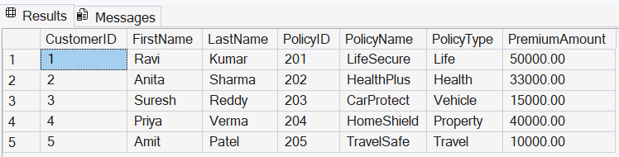
5.3:
Command: select cl.ClaimID, cl.ClaimDate,cl.ClaimAmount,cl.ClaimStatus,c.CustomerID,c.FirstName,c.LastName
from Claims cl
join PolicyAssignments pa
on cl.AssignmentID = pa.AssignmentID
join Customers c
on pa.CustomerID = c.CustomerID;
o/p:
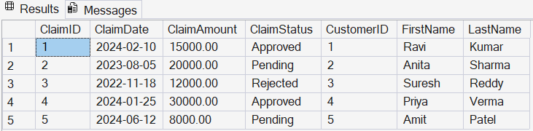
5.4:
Command: select c.FirstName, p.PolicyName, a.AgentName, pa.StartDate, pa.EndDate
from Customers c
join PolicyAssignments pa
on c.CustomerID = pa.CustomerID
join Policies p
on pa.PolicyID = p.PolicyID
join Agents a
on pa.AgentID = a.AgentID;

o/p:
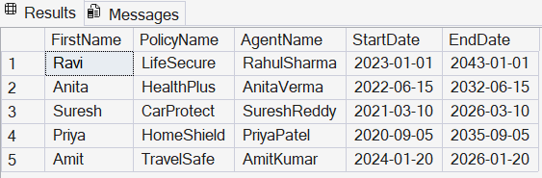
5.5:
Command: select c.FirstName, p.PolicyName, cl.ClaimAmount, cl.ClaimStatus, cl.ClaimDate
from Claims cl
join PolicyAssignments pa
on cl.AssignmentID = pa.AssignmentID
join Customers c
on pa.CustomerID = c.CustomerID
join Policies p
on pa.PolicyID = p.PolicyID;
o/p:
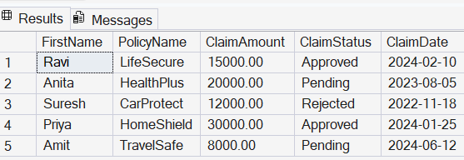
5.6:
Command: select c.CustomerID, c.FirstName, c.LastName, p.PolicyID, p.PolicyName
from Customers c
left join PolicyAssignments pa
on c.CustomerID = pa.CustomerID
left join Policies p
on pa.PolicyID = p.PolicyID;

o/p:
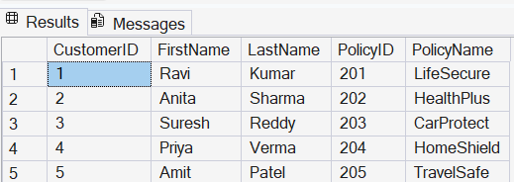
5.7:
Command: select c.CustomerID, c.FirstName, c.LastName
from Customers c
left join PolicyAssignments pa
on c.CustomerID = pa.CustomerID
left join Claims cl
on pa.AssignmentID = cl.AssignmentID
where cl.ClaimID is null;
o/p:

5.8:
Command: select c.CustomerID,cast(c.FirstName as varchar(50)) + ' ' + cast(c.LastName as varchar(50)) as CustomerName,
sum(cl.ClaimAmount) as TotalClaimAmount
from Customers c
join PolicyAssignments pa
on c.CustomerID = pa.CustomerID
join Claims cl
on pa.AssignmentID = cl.AssignmentID
group by
c.CustomerID,
cast(c.FirstName as varchar(50)),
cast(c.LastName as varchar(50));
o/p:
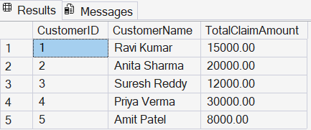

5.9:
Command: select c.CustomerID,cast(c.FirstName as varchar(50)) + ' ' + cast(c.LastName as varchar(50)) as CustomerName,
sum(cl.ClaimAmount) as TotalClaimAmount
from Customers c
join PolicyAssignments pa
on c.CustomerID = pa.CustomerID
join Claims cl
on pa.AssignmentID = cl.AssignmentID
group by
c.CustomerID,
cast(c.FirstName as varchar(50)),
cast(c.LastName as varchar(50))
having sum(cl.ClaimAmount) > 50000;
o/p:

5.10:
Command: select a.AgentID,a.AgentName,count(pa.PolicyID) as PolicyCount
from Agents a
left join PolicyAssignments pa
on a.AgentID = pa.AgentID
group by a.AgentID,a.AgentName;
o/p:
